**Document automation toolkit – AI Builder**

Where to find in the Power Platform (AUTOMATE) Environment?

[**https://flow.microsoft.com/manage/aibuilder/documentautomation**](https://flow.microsoft.com/manage/aibuilder/documentautomation)

[**https://unitedkingdom.flow.microsoft.com/manage/environments/{EnvironmentName-GUID}/aibuilder/documentautomation**](https://unitedkingdom.flow.microsoft.com/manage/environments/%7bEnvironmentName-GUID%7d/aibuilder/documentautomation)

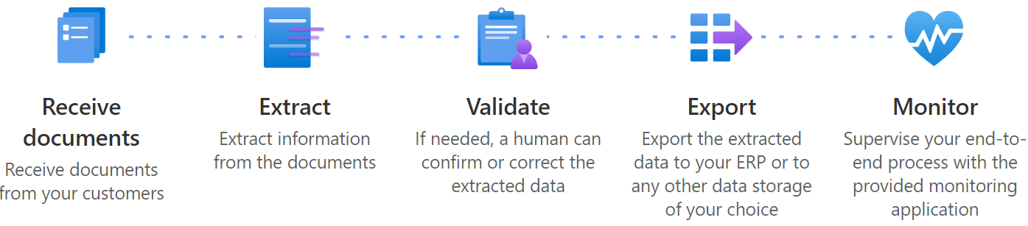

**What Is and How-To**

**“The Document automation toolkit allows you to easily set up a rich and robust document processing solution using AI Builder, Power Automate, Power Apps, and Microsoft Dataverse.”**

* [Document automation toolkit - **AI Builder | Microsoft Docs**](https://docs.microsoft.com/en-us/ai-builder/doc-automation)
* [Automate the processing of documents with the AI Builder prepackaged solution - **Learn | Microsoft Docs**](https://docs.microsoft.com/en-us/learn/modules/get-started-ai-builder-document-automation/)

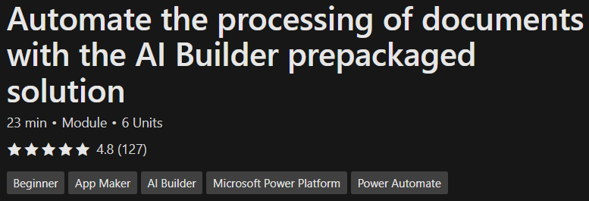

* [**Install the document automation base kit**](https://docs.microsoft.com/en-us/learn/modules/get-started-ai-builder-document-automation/2-install)
* [**Configure the document automation base kit**](https://docs.microsoft.com/en-us/learn/modules/get-started-ai-builder-document-automation/3-configure)
* [**Monitor and review processing documents with the document automation base kit**](https://docs.microsoft.com/en-us/learn/modules/get-started-ai-builder-document-automation/4-monitor)

**[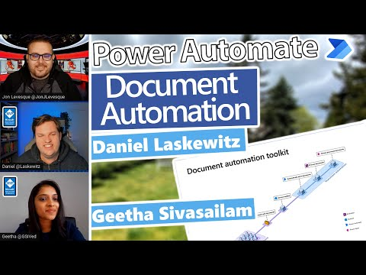](https://www.youtube.com/embed/mkiTk0ssTuk?feature=oembed) [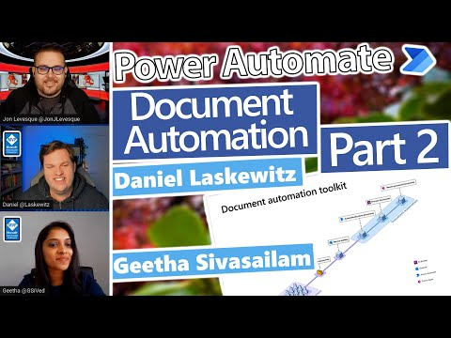](https://www.youtube.com/embed/9GndMPLof_4?feature=oembed) [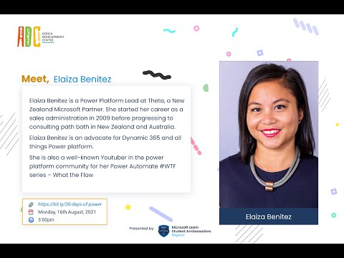](https://www.youtube.com/embed/X8Gi1OzusPc?feature=oembed) [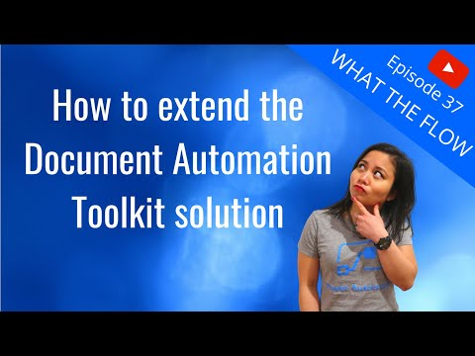](https://www.youtube.com/embed/GKmbdFXJ5aQ?feature=oembed)**

* + [AI Builder calculator](AI%20Builder%20calculator) : [**https://go.microsoft.com/fwlink/?linkid=2152072**](https://go.microsoft.com/fwlink/?linkid=2152072)

[**Overview of form processing model - AI Builder | Microsoft Docs**](https://docs.microsoft.com/en-gb/ai-builder/form-processing-model-overview)

**Installation & Setup/Configuration details**

**

1. Creating/Using a MS-Teams/Group and changing the group property to be SECURITYENABLED = $true

(Optionally) Setting the “M365 Group (with Teams)” As-A “Mail-Enabled Security Group” using M365 **PowerShell Modules**

|

Install-Module -Name MSOnline , AzureAD, Microsoft.Online.SharePoint.PowerShell , SharePointPnPPowerShellOnline, ExchangeOnlineManagement, MicrosoftTeams, Microsoft.Graph -AllowClobber -Force -Scope AllUsers

[Azure Cloud Shell overview | Microsoft Docs](https://docs.microsoft.com/en-us/azure/cloud-shell/overview)

* + - <https://portal.azure.com/#cloudshell/>

[Connect to all Microsoft 365 services in a single PowerShell window - Microsoft 365 Enterprise | Microsoft Docs](https://docs.microsoft.com/en-us/microsoft-365/enterprise/connect-to-all-microsoft-365-services-in-a-single-windows-powershell-window?view=o365-worldwide)

* + - [Install all Office 365 PowerShell Modules (o365reports.com)](https://o365reports.com/2019/11/01/install-all-office-365-powershell-modules/)

[Install the Microsoft Graph PowerShell SDK | Microsoft Docs](https://docs.microsoft.com/en-us/powershell/microsoftgraph/installation?view=graph-powershell-beta)

* + - Install-Module Microsoft.Graph -Scope AllUsers

WHILE MS-GRAPH SDK does provide additional properties on a GROUP – It was found that using AzureAD – provided the property “SECURITYENABLED”

1. Complete setting up the Document Automation Toolkit 🡪 From Power Automate 🡪 AI Builder

**\*\* If this error is encountered – attempt to create a dataverse (premium) connector based app/flow and start-trial-for-90-days on the same account/login as used in this document-automation-toolkit setup --** [Error: User does not have a service plan adequate for the non-Standard connection (microsoft.com)](https://support.microsoft.com/en-gb/topic/error-user-does-not-have-a-service-plan-adequate-for-the-non-standard-connection-44b9121f-2eb0-bcb0-60e6-6da0a5043dd2)

[Configure the document automation base kit - Learn | Microsoft Docs](https://docs.microsoft.com/en-us/learn/modules/get-started-ai-builder-document-automation/3-configure)

🡺 Add/Set the **System Customizer** role to **Process Owners** or the **Document Automation Reviewer** role to **Manual Reviewers**.

**

1. Document Automation Application (Canvas App) – Validation and CONFIGURATION Setup

Open the app – go to configuration tab and create a record based on the available AI model in the environment. Here a custom AI model was created and trained based on Excel data screenshots … and training & publishing the model.

**

1. **Document Automation Email Importer**

**Step 2: Document Processing …**

Email received in folder (Inbox) of the connection-login used to listen on outlook.com mailbox

The email importer runs and the validator upon save etc – from the Canvas app…

**

Using the app to Validate / Review the received/processed document.

**